**Hands on Exercise Chapter 3**

**Website #1**

a) URL of website: <http://www.saultcollege.ca/>

b) Name of website: Sault College

c)Target Audience: Staff and students

d) Picture of home page:

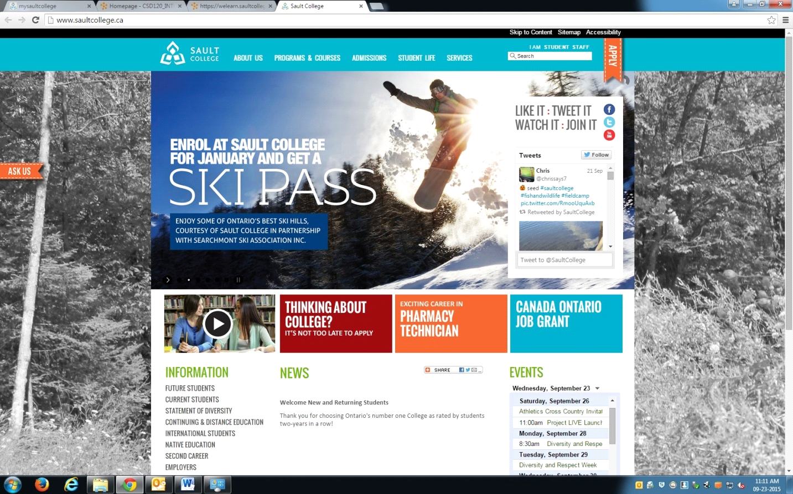

e) Types of navigation: Navigation bars, graphics, dynamic, site map, site search

f) Describe how the design principles are applied:

Repetition: the website uses the same layout for every page you go to on

the site, the menu bar, the logo, the side menu and color palette are all consistent throughout the website.

Contrast: the site uses black text on a white background for the most part,

which if the greatest contrast you can have. the color palette for the menu bar and the title text as well as other pictures and boxes are also a split complementary color scheme of a light blue with orange and a light green and reds

Proximity: navigation links such as the menu bar and information links are

space in such away as to create groups and therefore appear separate based on relevance.

Alignment: the layout of the subheadings in green as well as the box

links in the middle align in columns and create a visual unity across the site

G) **Web Design Checklist**

**Replace the** □ **with an** X **if the criteria is satisfied.**

**Page Layout Criteria**

X1. Consistent navigation area

X2. Informative page title that includes the company/organization/site name

□3. Page footer area—copyright, last update, contact e-mail address

X4. Good use of basic design principles: repetition, contrast, proximity, and alignment

X5. Displays without horizontal scrolling at 1024×768 and higher resolutions

X6. Balance of text/graphics/white space on page

X7. Repetitive information (header/logo and navigation) takes up no more than one fourth to one third of the browser window at 1024×768 resolution

X8. Home page downloads within 10 seconds of connection

**Navigation Criteria**

X1. Main navigation links are clearly and consistently labeled

X2. Navigation is easy for the target audience to use

X3. When the main navigation consists of images and/or multimedia, the page footer area contains plain text hyperlinks (accessibility)

X4. Navigational aids, such as site map, skip to content link, or breadcrumbs, are used

**Color and Graphics Criteria**

x1. Use of different colours is limited to a maximum of three or four plus neutrals

x2. Colour is used consistently

x3. Background and text colors have good contrast

x4. Colour is not used alone to convey meaning (accessibility)

x5. Use of colour and graphics enhances rather than distracts from the site

x6. Graphics are optimized and do not slow download significantly

x7. Each graphic used serves a clear purpose

X8. Animated images do not distract from the site and do not loop endlessly

**Multimedia Criteria**

X1. Each audio/video/Flash file used serves a clear purpose

X2. The audio/video/Flash files used enhance rather than distract from the site

x3. Captions or transcripts are provided for each audio or video file used (accessibility)

**Content Presentation Criteria**

□1. Common fonts such as Arial or Times New Roman are used

x2. Techniques of writing for the Web are applied: headings, subheadings, bulleted lists, short sentences in brief paragraphs, use of white space

x3. Fonts, font sizes, and font colors are consistently used

x4. Content provides meaningful, useful information

x5. Content is organized in a consistent manner

□6. Information is easy to find (minimal clicks)

□7. Timeliness: The date of the last revision and/or copyright date is accurate

x8. Content is free of typographical and grammatical errors

x9. Avoids the use of “Click here” when writing text for hyperlinks

□ 10. Hyperlinks use a consistent set of colours to indicate visited/non-visited status

X11. Alternate text equivalent of content is provided for graphics and media (accessibility)

**Functionality Criteria**

x1. All internal hyperlinks work

x2. All external hyperlinks work

x3. No error messages are generated by the pages

**Browser Compatibility Criteria**

x1. Displays on current versions of Internet Explorer (9+)

x2. Displays on current versions of Firefox

x3. Displays on current versions of Google Chrome

x4. Displays on popular mobile devices (including tablets and smartphones)

H) Three recommendations

1) the drop down submenus of the main menu bar have a seemingly large amount of links within them, this could possibly be trimmed down or have sub categories.

2) There is a link to a video which displays as though it can be played within the site but it instead opens to youtube in a separate tab, this perhaps could uses an embedded link which could play from the Sault College site instead.

3) The links under the Information side menu don't immediately stand out as links as they are the same color as the normal text, maybe a different color would make them stand out more.

**Website #2**

a) URL of website: http://www.lingscars.com/

b) Name of website: Ling's Cars

c)Target Audience: Adults

d) Picture of home page:

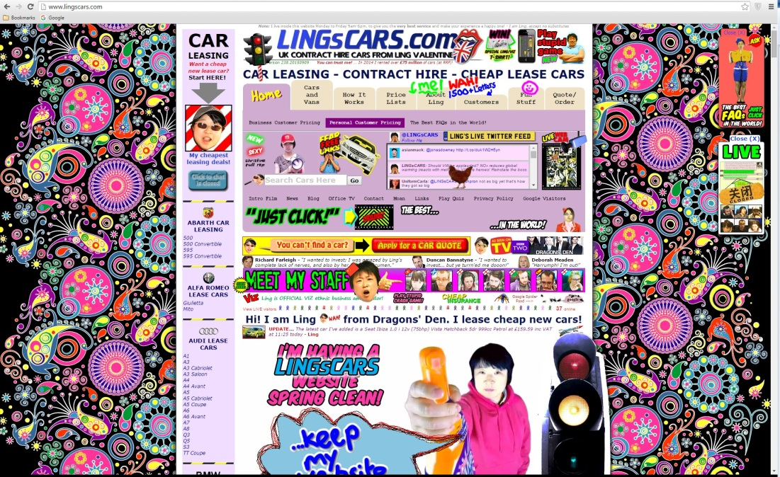

e) Types of navigation: Navigation bars, graphics, site search

f) Describe how the design principles are applied:

Repetition: the website uses a menu bar at the top of all of the pages. the unorganized and seemingly random nature of the site could be seen as a running theme

Contrast: the site uses black and colored text on a mostly white background. Red, blue and green seem to be the main font colors with shades of purple and yellow/brown, together these to not form a cohesive color scheme

Proximity: the spacing of many of the different bars and links are all

very close making separation difficult to perceive. Rather than a cohesive structure the whole page just seems to blend into one continuous block of information.

Alignment: for the most part there doesn't appear to be much thought put

into creating a structured and well organized site, if there is alignment of the menus and links it is made difficult to see as the many pictures and animated graphic draw attention in a scattershot fashion.

G) **Web Design Checklist**

**Replace the** □ **with an** X **if the criteria is satisfied.**

**Page Layout Criteria**

X1. Consistent navigation area

X2. Informative page title that includes the company/organization/site name

X3. Page footer area—copyright, last update, contact e-mail address

□ 4. Good use of basic design principles: repetition, contrast, proximity, and alignment

X5. Displays without horizontal scrolling at 1024×768 and higher resolutions

□ 6. Balance of text/graphics/white space on page

□ 7. Repetitive information (header/logo and navigation) takes up no more than one fourth to one third of the browser window at 1024×768 resolution

□ 8. Home page downloads within 10 seconds of connection

**Navigation Criteria**

□ 1. Main navigation links are clearly and consistently labeled

□ 2. Navigation is easy for the target audience to use

□ 3. When the main navigation consists of images and/or multimedia, the page footer area contains plain text hyperlinks (accessibility)

□ 4. Navigational aids, such as site map, skip to content link, or breadcrumbs, are used

**Color and Graphics Criteria**

□ 1. Use of different colours is limited to a maximum of three or four plus neutrals

□ 2. Colour is used consistently

□ 3. Background and text colors have good contrast

x4. Colour is not used alone to convey meaning (accessibility)

□ 5. Use of colour and graphics enhances rather than distracts from the site

□ 6. Graphics are optimized and do not slow download significantly

□ 7. Each graphic used serves a clear purpose

□ 8. Animated images do not distract from the site and do not loop endlessly

**Multimedia Criteria**

□ 1. Each audio/video/Flash file used serves a clear purpose

□ 2. The audio/video/Flash files used enhance rather than distract from the site

□ 3. Captions or transcripts are provided for each audio or video file used (accessibility)

**Content Presentation Criteria**

x1. Common fonts such as Arial or Times New Roman are used

□ 2. Techniques of writing for the Web are applied: headings, subheadings, bulleted lists, short sentences in brief paragraphs, use of white space

□ 3. Fonts, font sizes, and font colors are consistently used

□ 4. Content provides meaningful, useful information

□ 5. Content is organized in a consistent manner

□ 6. Information is easy to find (minimal clicks)

x7. Timeliness: The date of the last revision and/or copyright date is accurate

x8. Content is free of typographical and grammatical errors

□ 9. Avoids the use of “Click here” when writing text for hyperlinks

□10. Hyperlinks use a consistent set of colours to indicate visited/non-visited status

□11. Alternate text equivalent of content is provided for graphics and media (accessibility)

**Functionality Criteria**

x1. All internal hyperlinks work

x2. All external hyperlinks work

x3. No error messages are generated by the pages

**Browser Compatibility Criteria**

x1. Displays on current versions of Internet Explorer (9+)

x2. Displays on current versions of Firefox

x3. Displays on current versions of Google Chrome

x4. Displays on popular mobile devices (including tablets and smartphones)

H) Three recommendations

1) Restructure and organize the main menu bar to make it easier to see and use. Provide some space between different sections.

2) Removing many of the animated graphic would help to make the site much less cluttered and distracting.

3) Use a more consistent color scheme throughout the page.